★★☆☆☆
題組：基礎48題
題號：Uva356:Square Pegs And Round Holes
整理者：鄭紹雄
學號：ACS105103
使用語言:C++
解題日期：2018年8月18日
題目:
A circle 2n − 1 units in diameter has been drawn centered on a 2n by 2n chessboard. The construction for n = 3 is illustrated below.
Write a program that will determine the number of cells of the board which contain a segment of the circle and the number of cells of the board which lie entirely inside the circle.
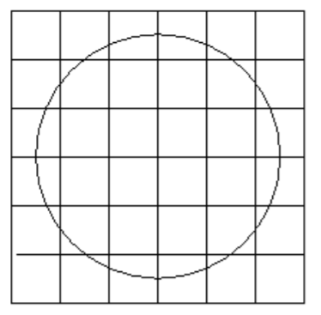
Input
Each line of the input file will contain a positive integer no greater than 150.
Output
For each input value n, write two statements on consecutive lines of the output file in the format
indicated in the sample output. Follow this with a blank line to separate your output for successive inputs.
Sample input
3
4
Sample output
In the case n = 3, 20 cells contain segments of the circle.
There are 12 cells completely contained in the circle.
In the case n = 4, 28 cells contain segments of the circle.
There are 24 cells completely contained in the circle.
問題描述：
在一個邊長為 2n 的正方形棋盤中央畫一個直徑為 2n-1 的圓，以下的圖為n=3
寫一個程式判斷有多少個格子是一部份在圓中，以及有多少個格子是完全被包含在圓當中。
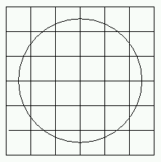
Input
輸入包含好幾組測試資料，每組一列，含有一個正整數 n（n<=150）
Output
對每一組測試資料，輸出2列，第一列為部分被包含在圓中的格子數。第二列為完全被包含在圓中的格子數。
請注意：各測試資料之間要空一列。請參考Sample output
Sample Iutput
3
4
Sample Output
In the case n = 3, 20 cells contain segments of the circle.
There are 12 cells completely contained in the circle.
In the case n = 4, 28 cells contain segments of the circle.
There are 24 cells completely contained in the circle.

解法：
此題可以藉由圓形對稱的方式切成4份下手，最後數量再弄回來就OK
解法範例：
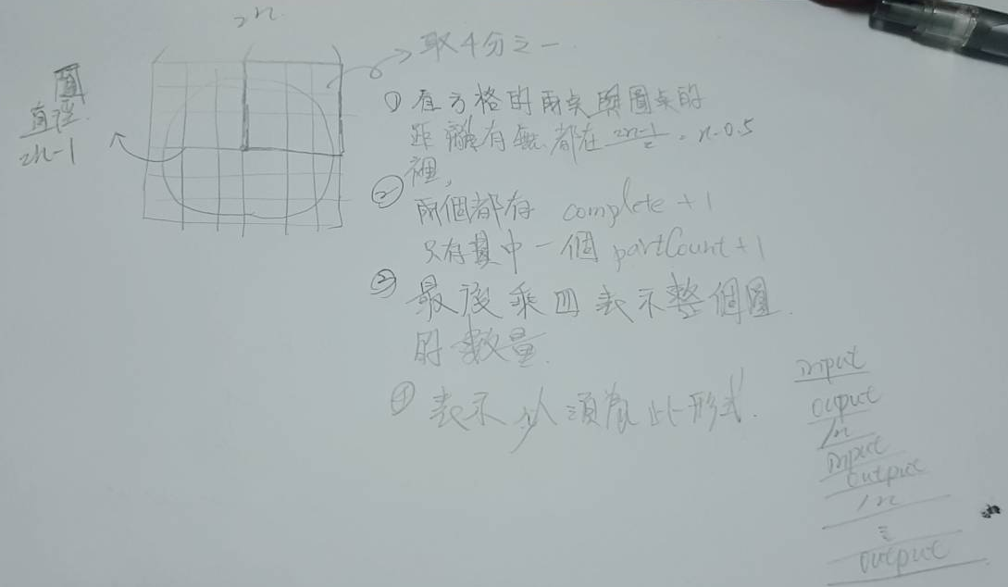
討論:
此題只要找到方法之後並不困難

程式:
#include<iostream>
#include<cmath>
#include<cstdio>

using namespace std;

double radis(int,int);

int main(){

double input;
int flag=0;
while(cin>>input){
//最後一行不要換行
if(flag)
cout<<endl;
flag = 1;
int countComplete=0;
int partCount=0;
//判斷有沒有完全在圈圈裏面 或是部分
for(int i=0;i<=input;i++){
for(int j=0;j<=input;j++){

if(radis(i,j)<=(input-0.5)&&radis(i+1,j+1)<=(input-0.5)){

countComplete++;
}else if(radis(i,j)<=(input-0.5)||radis(i+1,j+1)<=(input-0.5)){
partCount++;
}
}
}
//最後數量要乘4
printf("In the case n = %d, %d cells contain segments of the circle.\n",(int)input,partCount*4);
printf("There are %d cells completely contained in the circle.\n",countComplete*4);
}
}
//原點到點的距離
double radis(int x,int y){

return sqrt(pow(x,2)+pow(y,2));

}

